Page 1


SUMMER TRAINING REPORT
Data Structure and Algorithms (Cipher Schools)
Submitted To:
School Of Computer Science And Engineering
Lovely Professional University,
Phagwara
Submitted By: D Pavan Kumar
12212392
Page 2

Declaration
I am Dasari Pavan Kumar hereby declare that I have completed my 10 weeks summer training at Cipher Schools. I herby ensure that I have worked with full dedication during these 10 weeks of training and my learning outcomes fulfil the requirements of training for the award of degree of Computer Science and Engineering, Lovely Professional University,

Acknowledgement
This Summer Training Program taken by me under Cipher Schools helped me in a way that I never expected. Never would have I known in detail about DSA without taking this project.
My University is also to be thanked, had they not given me a chance to do this training, I would not have this current level of excellence over this topic.
Page 3


And the one I would like to thank the most is my family. During this time of Online Classes, had they not given me the support, I don't think I would have been able to complete
this project on time.

5

Certificate
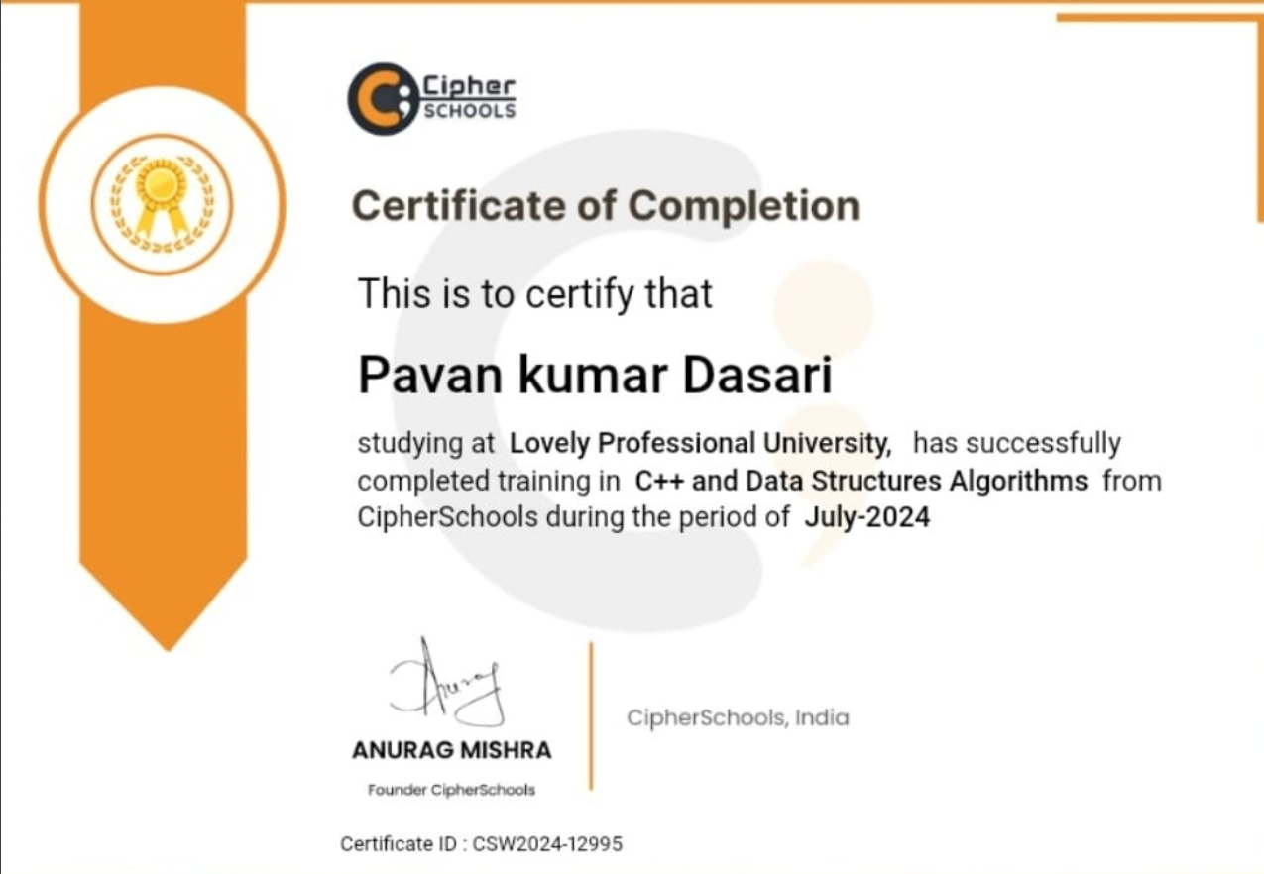


^{Table of Contents}

1 | Introduction
2 | Technology Learnt
3 | Reason For Choosing DSA
4 | Learning Outcome For Technology Learnt
5 | Bibliography

INTRODUCTION
When most people hear the word "algorithm," they think of a complicated set of instructions that are often difficult to understand. In reality, an algorithm is simply a series of steps that gets you from one point to another. A computer program also contains algorithms, but it's not always clear

what the difference between an algorithm and a program is! This blog post will
help you better understand how these two things work together- so read on for more details!
What is an algorithm?
An algorithm is typically a formal set of steps that gets you from point A to point B. It's not necessarily complicated, but it does get the job done! An example of an algorithm would be figuring out how much money someone should pay for lunch with this equation:
Lunch cost = price per plate x number of people eating + drink cost
In order to determine whether or not something has an algorithmic quality about it, you can ask yourself if there are specific rules and steps involved in getting from one place to another. If so- congrats! You've found what might be considered "algorithmic!" What is a program?
A computer program contains algorithms as well, which essentially means that a program is simply an algorithm. Here are some of the similarities and differences between programs and algorithms:
Similarities: Algorithms can be used to solve problems by breaking down complex tasks into simpler ones, which helps you get from point A to B faster! Programs do this as well- for example, a word processor has algorithmic processes in order to make your writing process easier.
Differences: Both algorithms and computer programs work through the same series of steps or set of rules; however, not all programs are strictly written out with instructions that tell you exactly what needs to happen next. If there's one step left open, then it's no longer considered an "algorithm" but rather just a "program."

How programs use algorithms:
Programs rely on algorithms to help them figure out what step in the program they should do next. For example, if you wanted to download a song from Spotify, your computer would need an algorithm to tell it how long that process will take. If not programmed correctly- this might mean hours of waiting!
Algorithms vs Programs
A Program is an algorithm with additional code added so it can execute its commands while still being able to accomplish many tasks whereas an Algorithm is just one specific instruction from which all functions are calculated from but not executed.
We hope this has helped you understand what The Difference Between an Algorithm and a Program could mean! If there's anything else we missed or if you need any clarification whatsoever please let us know in the comments section below and we'll get back to you as soon as possible!

Technology Learnt

Complexity
The whole DSA according to my perspective revolves around Complexity and mainly Time Complexity.
Complexity in this filed is broadly classified into 2 types namely Time and Space complexity.
Time Complexity: Algorithm's time complexity is the amount of time taken by an algorithm to run as a function for the given input.
In simpler terms, If c is the execution time of an algorithms basic operation on a particular computer and if C(n) be the number of times an operation is run on input n, then time complexity of a program can be approximately calculated as,

T(n)= c*C(n)
It is analysed by determining the number of repetitions of the basic operation as a function of input size. Basic operation is the one that contributes the most towards the running time of the algorithm.
It is generally expressed using big O notation. Big O notation excludes coefficients and lower order terms.

Since an algorithm's time complexity may vary with different inputs of the same size, the commonly used is the worst case time complexity of an algorithm. The worst case time complexity of an algorithm gives the maximum amount of time taken on any input size n.

Types of Time Complexity:
- Big Oh
- Big Omega 3. Big Theta

Big Oh:
Big O notation is used in Computer Science to describe the complexity of an algorithm. In short, it is the language we use for talking about how long an algorithm takes to run. It specifically describes the worst-case scenario and provides an approximation of how quickly space or time complexity grows relative to the input size.

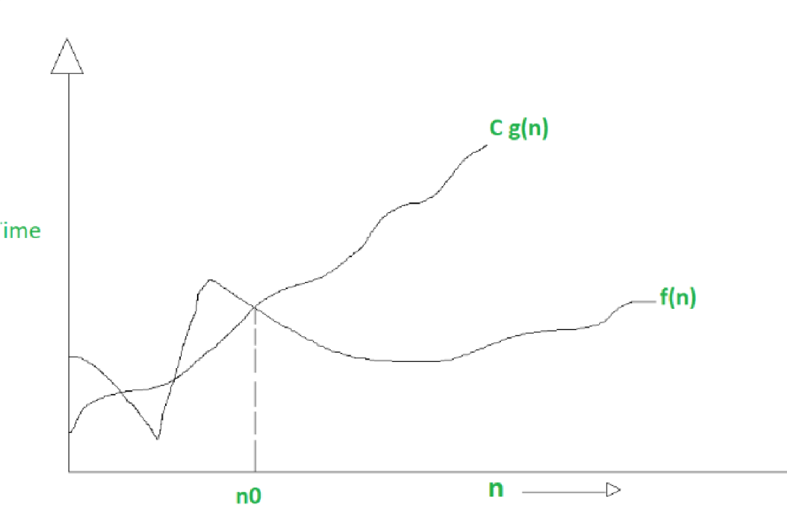

Big Omega:
Just like O notation provides an asymptotic upper bound, Omega notation provides asymptotic lower bound.
Let f(n) define running time of an algorithm:

O<= C g(n) <= f(n) for all n>=n 0

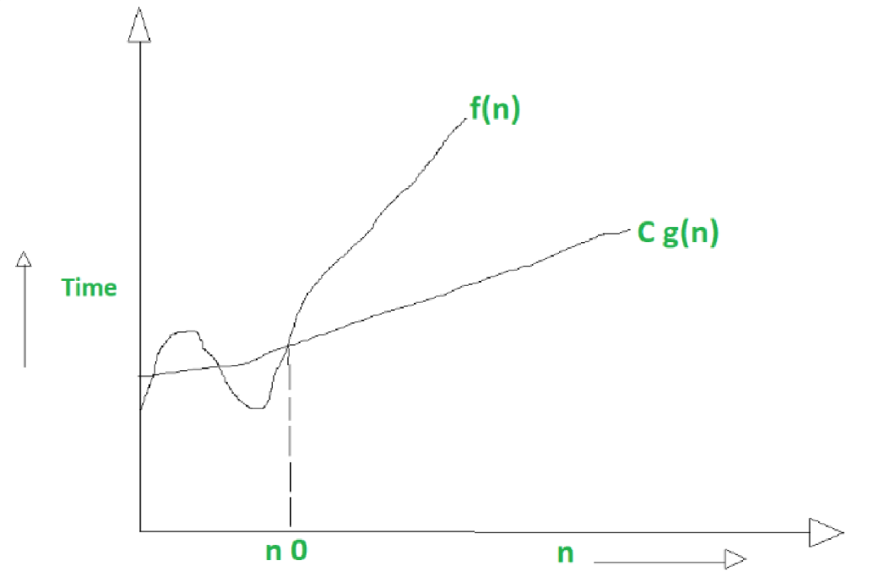
Big Theta:
Theta notation encloses the function from above and below. Since it represents the upper and the lower bound of the running time of an algorithm, it is used for analysing the average-case complexity of an algorithm.

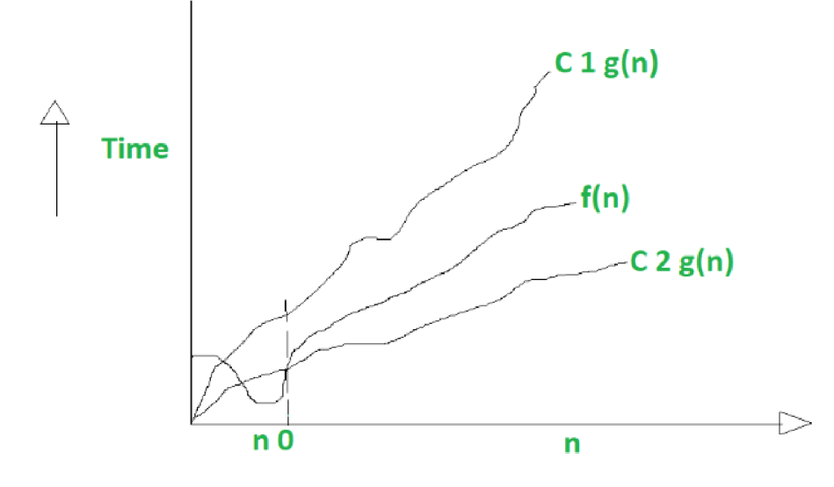

Basic Operations in DSA
Searching and Sorting:
In Data Structure, Searching and sorting also have the same meaning as in our real life.
Searching : Find something
Sorting : To put something in order.
Two things are required for searching and sorting
- Data
- Something in which we can keep data (Data Structure)
If we do not have anything in which we can keep data, then how will we keep the data? And when there is no data, what is the job of searching and sorting?
So the data structure is the one we use to hold data, example
- Array, Linked List, trees, Binary trees, Graph, Stack, Queues etc.
And searching means finding the required data in the data structure and there are many techniques
- Linear search
- Binary Search
- BFS
- DFS etc

And sorting means to sort the data in increasing or decreasing order and there are many techniques which are used on different data structures, example :
- Selection sort
- Bubble Sort
- Insertion Sort
- Merge Sort
- Quick Sort and many many more Insertion and Deletion:
Insert operation is to insert one or more data elements into an array. Based on the requirement, new element can be added at the beginning, end or any given index of array. Here, we see a practical implementation of insertion operation, where we add data at the end of the array. Deletion refers to removing an existing element from the array and re-organising all elements of an array.

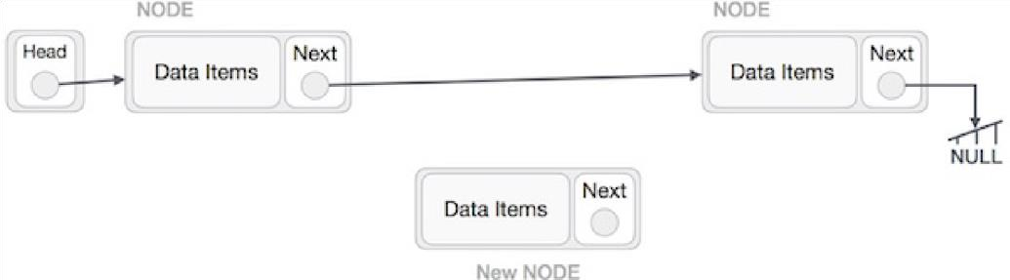
Insertion
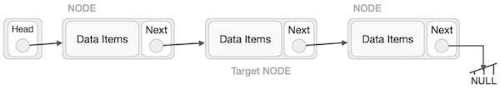
Deletion

Data Types
Data type is a way to classify various types of data such as integer, string, etc. which determines the values that can be used with the corresponding type of data, the type of operations that can be performed on the corresponding type of data. There are two data types namely:
- Built-In Data Type
- Derived Data Type
Built-In Data Types:
Those data types for which a language has built-in support are known as Built-in Data types. For example, most of the languages provide the following built-in data types.
Ex:
1. Integers
2.Boolean( Either True or False)
- Characters and Strings
- Floating
Derived Data Types:
Those data types which are implementation independent as they can be implemented in one or the other way are known as derived data types. These data types are normally built by the combination of primary or built-in data types and associated operations on them.
Ex.
- Arrays
- Queue
- Stack
- List

Linked Lists
A linked list is a sequence of data structures, which are connected together via links
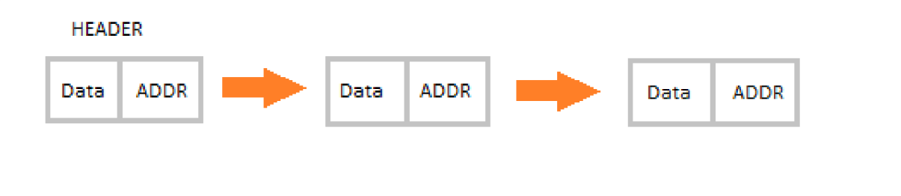
Demonstration of Linked Lists
Linked List is a sequence of links which contains items. Each link contains a connection to another link. Linked list is the second most-used data structure after array. Following are the important terms to understand the concept of Linked List.
Linked lists are namely of three different types:
- Singly Linked Lists
- Doubly Linked Lists
- Circular Linked Lists
All the basic operation discussed earlier like insertion, deletion, searching, and sorting, etc are all performed on Linked Lists.
Singly Linked Lists:
Singly linked lists contain nodes which have a data part as well as an address part i.e. next, which points to the next node in sequence of nodes. The operations we can perform on singly linked lists are insertion, deletion and traversal.
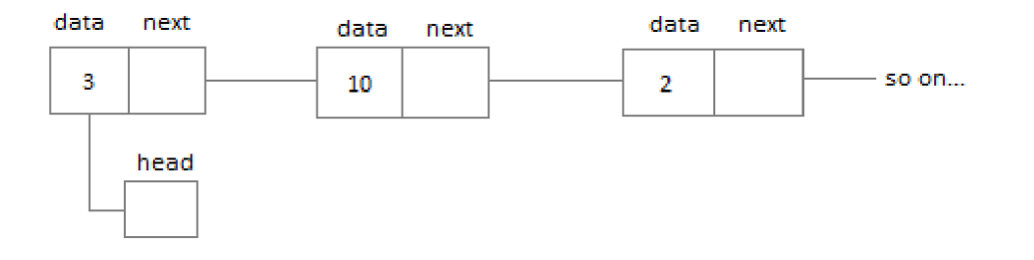
Demonstration of Singly Linked Lists
Doubly Linked Lists:
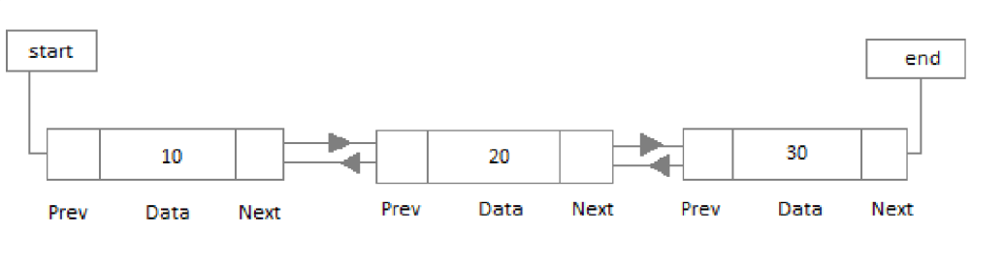
Demonstration of Doubly Linked List
In a doubly linked list, each node contains two links the first link points to the previous node and the next link points to the next node in the sequence.
Circular Linked List:
In the circular linked list the last node of the list contains the address of the first node and forms a circular chain.
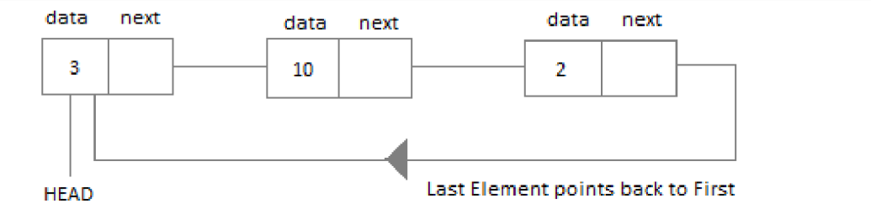
Circular Linked List

Stack and Queue
Stack:
A stack is an Abstract Data Type (ADT), commonly used in most programming languages. It is named stack as it behaves like a real-world stack, for example – a deck of cards or a pile of plates,
etc.
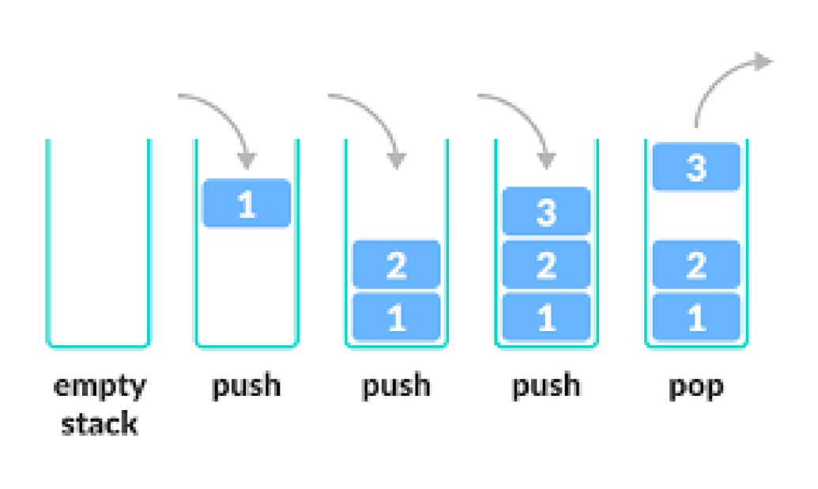
Stack Operations

A real-world stack allows operations at one end only. For example, we can place or remove a card or plate from the top of the stack only. Likewise, Stack ADT allows all data operations at one end only. At any given time, we can only access the top element of a stack.

This feature makes it LIFO data structure. LIFO stands for Last-in-first-out. Here, the element which is placed (inserted or added) last, is accessed first. In stack terminology, insertion operation is called PUSH operation and removal operation is called POP operation.

Queue:
Queue is an abstract data structure, somewhat similar to Stacks. Unlike stacks, a queue is open at both its ends. One end is always used to insert data (enqueue) and the other is used to remove data (dequeue). Queue follows First-In-First-Out methodology, i.e., the data item stored first will be accessed first.
Basic Operations in Queue:
- Enqueue() : adds an item to the queue
- Dequeue() : removes an item from the queue
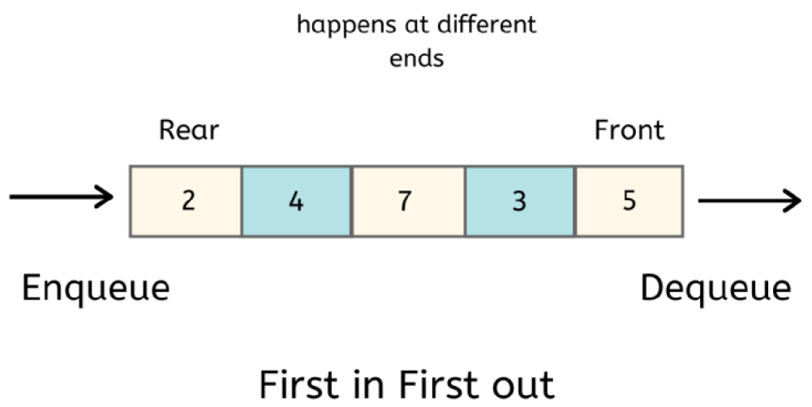
Queue Representation

Tree Data Structure
Tree represents the nodes connected by edges. We will discuss binary tree or binary search tree specifically
Binary Tree is a special data structure used for data storage purposes. A binary tree has a special condition that each node can have a maximum of two children. A binary tree has the benefits of both an ordered array and a linked list as search is as quick as in a sorted array and insertion or deletion operation are as fast as in linked list.

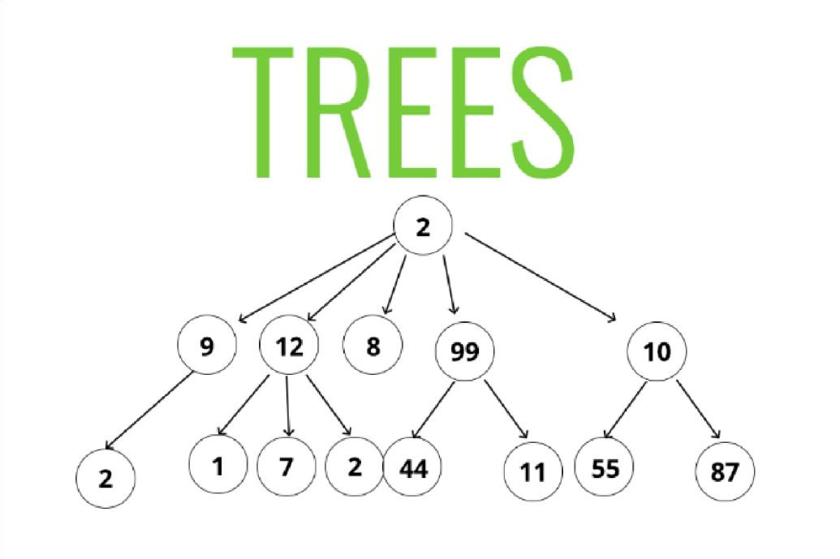
Tree Data Structure

Important Terms Related To Tree:
Path − Path refers to the sequence of nodes along the edges of a tree.

Root − The node at the top of the tree is called root. There is only one root per
tree and one path from the root node to any node.
Parent − Any node except the root node has one edge upward to a node called parent.
Child − The node below a given node connected by its edge downward is called its child node.

Leaf − The node which does not have any child node is called the leaf node.
Traversing − Traversing means passing through nodes in a specific order.
Levels − Level of a node represents the generation of a node. If the root node is at level 0, then its next child node is at level 1, its grandchild is at level 2, and so on. keys − Key represents a value of a node based on which a search operation is to be carried out for a node.
Visiting − Visiting refers to checking the value of a node when control is on the node.
Subtree − Subtree represents the descendants of a node.

Reason For Choosing DSA
After taking this Summer Training, I finally understood as why everyone was always determined about this topic "Data Structure and Algorithm".

Finally having learnt the importance of DSA in placements, I decided to take the summer training in this topic. I must say that, after taking this course, not only it has made me placement ready, but has also cleared a lot on my doubts that nearly most of coding students have.
This course is a complete package that helped me learn Data Structures and algorithms from basic to an advanced level. The course curriculum has been divided into 10 weeks where you can practice questions & attempt the assessment tests according to my own pace. The course offers me a wealth of programming challenges that will help me to prepare for interviews with top-notch companies like Microsoft, Amazon, and Adobe etc.

Learning Outcomes

Firstly, it has cleared numerous doubts of mine that I had about various algorithms. Secondly, the very known fact that it greatly helps in clearing placements cannot be ignored too. I am thus very delighted that I chose to do the summer training in this topic.
Also, after having done this training, I am very confident that I will be able to move from intermediate to advanced level of problems. Finally, now I can lay my hands of complex problems as well

Bibliography
There are numerous sources that helped me make this report up to mark as it is. Some of them are:- 1. Content of the Video Lecture
- Cipher Schools reading materials.
- Tutorials Point
- Multiple books based on Algorithm.

THANK YOU

